Movie Discovery: An AI and HCI Recommendation System

Satyasree
[Institution Name]
Artificial Intelligence for Human–Computer Interaction
[Instructor Name]
November 5, 2026

Recommendation Systems and Theoretical Foundations
Recommendation systems usually make ranks of items based on likelihood of relevance of situation or people. Such would reduce the need for exploring huge collections, entertainment decisions, education and shopping. In movie discovery, such ideas are applied through mobile catalogue with graphic an interface. In this project, the objective is to come up with AI recommendations system while addressing challenges in human-computer interaction (HCI) design.
With content-based filtering, there is comparison of the item attributes which would have the interests of the users. The collaborative filtering would learn from the interactions patterns across items and users; hybrid approach would combine several evidence sources. According to Lubos et al. (2023), taking a review on such approaches for video recommendation while finding out continuing research issues. Content-based filtering would be appropriate for the project since it has genres and descriptions available. Such would make the recommendation process inspectable. The project focused on coming up with a good design that would take consideration of the usability, and accessibility of use by the users. It utilizes the scikit-learn and python framework in deployment. It takes implementation through text-processing method with explorations, feedback, and movie-specific filtering.

Development Process and Interface
The development process started be definition of the outputs and input requirements. Users had selection of the movie, with genres, and certain maximum runtime. Results then mended to exclude the selected movie, avoid duplications, respect constraints, offer understandable explanations. Python would supply implication language, and streamlet would form the browser interface, NumPy offered numerical operations, and tabular processing was done by pandas.
The self-contained CSV had 36 fictional movies where original illustrative years, genres, AI-assisted descriptions and runtimes were contained. Such avoided the reliance of the external services for movies, even though it would limit realism. The process of validation had rejected missing columns, blank descriptions, duplicate identifiers and numeral values that were invalid. The upload control had supported the replacement catalogs, with download controls exporting the recommendations. Figure 1 shows the selected movie, catalog information, and preference controls. The permeation would serape the interface code and the recommendation logic, with every aspect made Asier in inspecting and testing. Dependency files with setup instructions had supported the reproducibility. With the interface, there is utilization of the selection controls instead of requiring the users in formulating the prompts that are natural-language like.
Figure 1. Movie Selection and Preference Controls
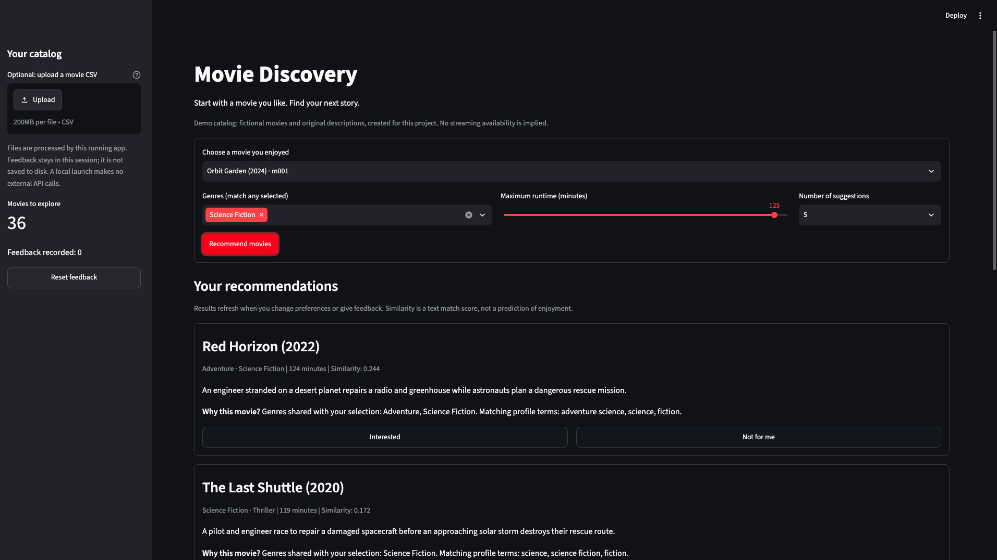
Note. There interface depicts the Orbit Garden selection, with the 125-minute runtime threshold, Science Fiction genre, and 5 requested suggestions.

Recommendation Logic and Explanations
The engine had combination of every description with the genre text repeated and fits on TF-IDF vectorizer through utilization of English stop-word removal, bigrams, unigrams, as well as term frequency. The TF-IDF offers terms numerical weights which would show the frequency in the document and the related distinctiveness over the collection. With eh cosine similarity, there is comparison of the selected vector of the movie with every candidate vector. Those candidates which would not have positive suability got omitted.
Figure 2. Ranked Recommendations With Explanations
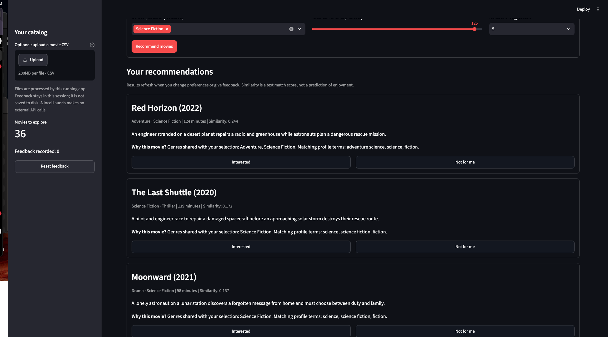
Note. Red Horizon takes a lead on the captured results. There is descriptive information, shared features, similarity scores with feedback controls shown int eh cards.
Any-selected rule was utilized by the genre choices, whereas runtime formed the upper hard limit. The movies thar remained got ranked based on descending similarity, where identifier and title offered deterministic tie-breaking features. Explanations had shown genres sharing the selected movie with high-contribution terms that war shared having the current profile. Such descriptions had overlap, not claiming about why one would enjoy a film. Figure 2 depicted the Red Horizon which was ranked first for similarity of .244 in capturing settings. Such lightweight approach Ould be essentialia but it would be dependent on the vocabulary. Also, meanings that were similar expressed different wors with varying weak matches, whereas the common genre had labels with dominated explanations. A huge evaluation may compare such features with semantic embeddings and would turn genera weights.

Feedback and Human–Computer Interaction
For the interface there were factors which ere interesting but buttons with issues, visible counters of feedback, a Nd resetting control. Feedback that was positive had half the mean iced vector for the seed profile. Rated movies had dispersed from the results that followed. Such weights would be designed with heuristics instead of parameters that would establish through the research of the user.
Figure 3: Recommendations After Three Feedback Actions
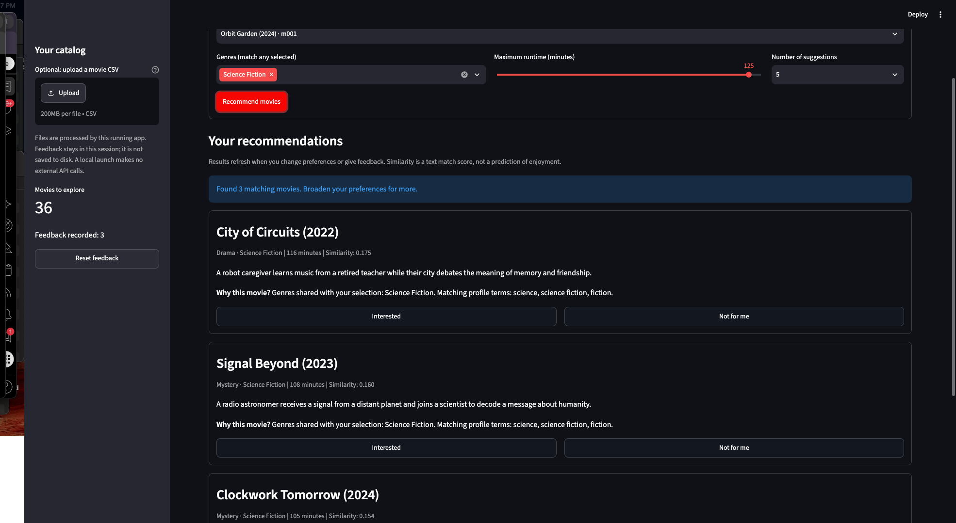
Note. The sidebar had a record on 3 feedback actions. The three movies had remained, ant the interforce offered guidance on the broadening preferences.
Figure 3 had shown records on three feedback actions, which would appear first among the recommendations. Such shows the updated interarea state that had no need of proving relevance that was improved. The feedback stays in the current session where users would not reset, and there is clearing of the catalogue.

Ethical Challenges and Mitigation
Ethical design needed concrete data decisions, control, and explanations. Prem (2023) points out that board AI concepts need contextual methods with tools so that they are actionable. In this aspect, privacy would be supported by session-only feedback with local operation with no external recommendation tools like APIs. But uploaded catalogues would get cached in the running state such that sharing deployment would need more governance.
Figure 4 Algorithm Transparency and Resource Attribution
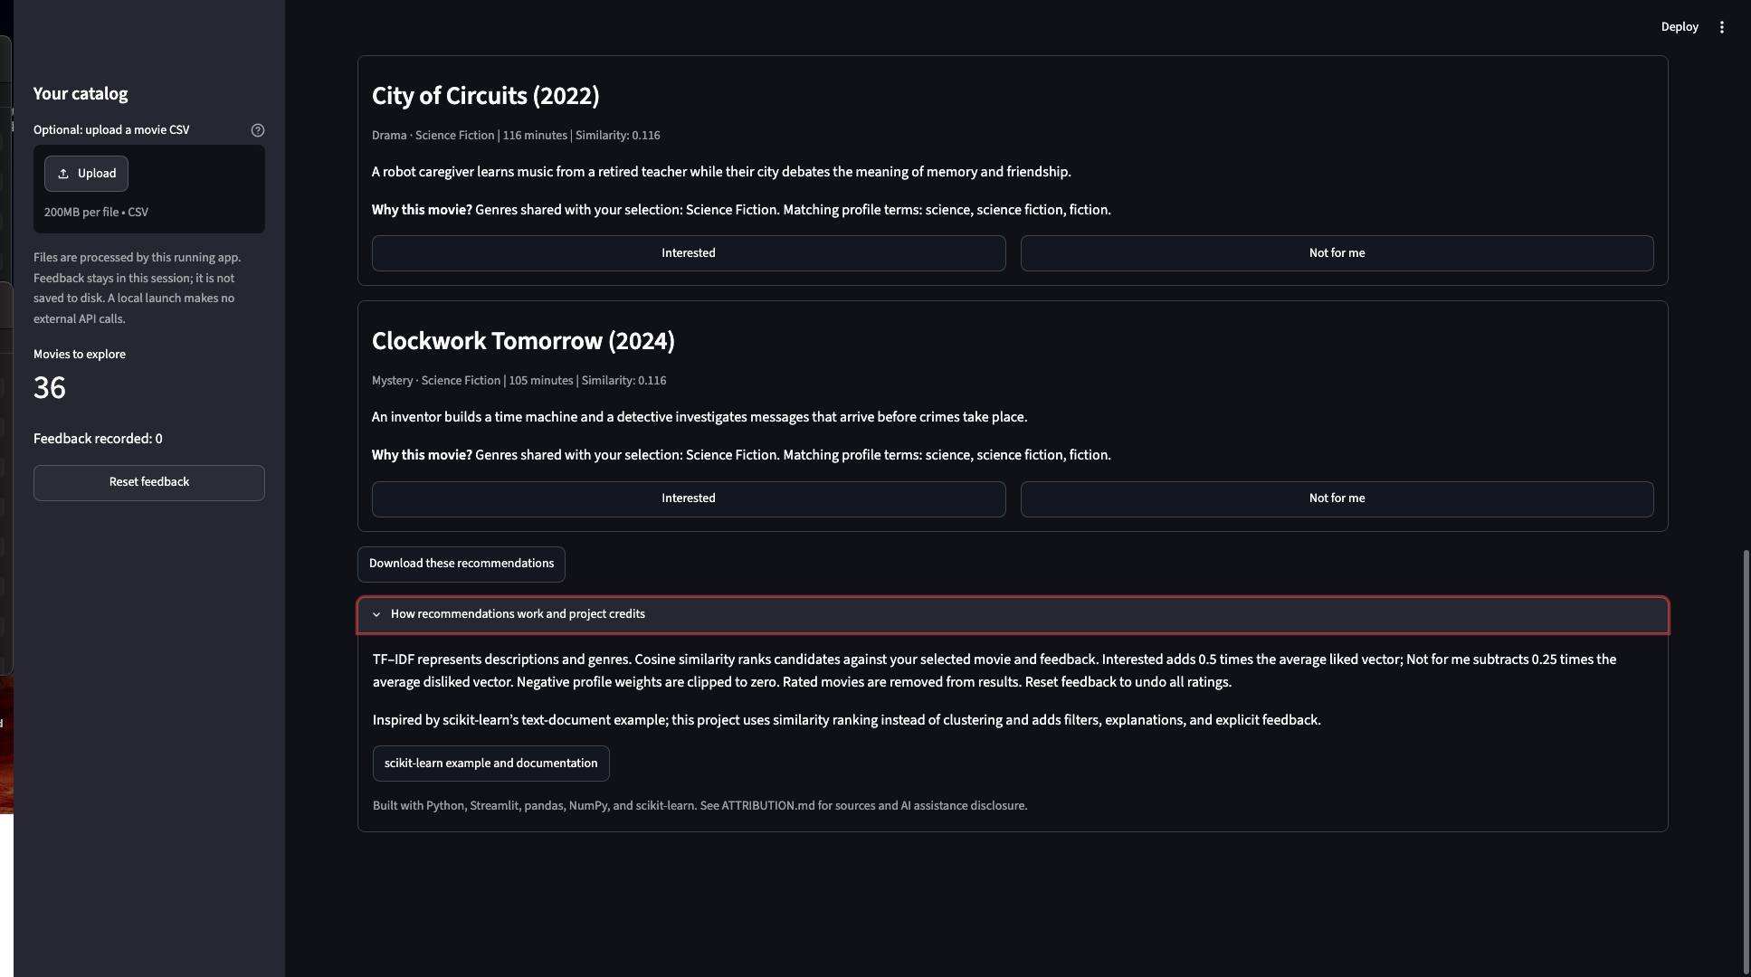
Note. The panel that Is expanded illustrates the method for recommended movie would involve credit on technical foundation. Separation control export recommendations that were performed.
With transparency, there is identification of the fictional dataset, distinguishing of similarity, and crediting resources. Figure 4 depicts the attribution and expiation panel. The dataset would cover the remaining concerns with small readable catalogue which Ould not establish the fruitiness culture in representation of preferences of the movie that are diverse. Future evaluation to examine the accessibility, exposure and coverage instead of making the relevance as the objective that only exists.

Evaluation, Challenges, and Reflection
The tests I did got passed, which covered the constraints in recommendations, effects in feedback, interface interaction and malformed data. The local server had returned success in the process. An empty-result message was inserted as an exception handler when the one minute is entered which means it is erroneous since no movie is 1 minute (Figure 5).
Figure 5: Guidance When No Movies Match the Preferences
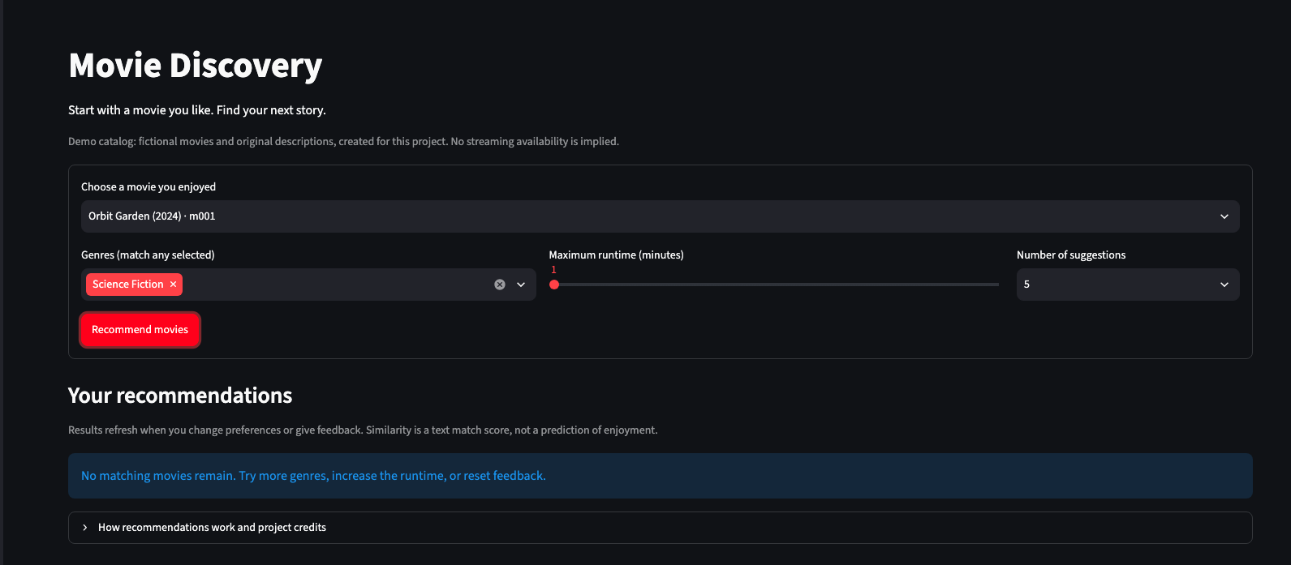

Such checks would establish behavior the tis functional, not only accuracy in recommendation. In this project, there is the illustration of the algorithmic choices in interaction choices; feedback, filtering, and explanations aspects. For future assistants, typed request can be combined with voice and suggestions that are proactive.

References
Lubos, S., Felfernig, A., & Tautschnig, M. (2023). An overview of video recommender systems: State-of-the-art and research issues. Frontiers in Big Data, 6, Article 1281614. https://doi.org/10.3389/fdata.2023.1281614
Prem, E. (2023). From ethical AI frameworks to tools: A review of approaches. AI and Ethics, 3, 699–716. https://doi.org/10.1007/s43681-023-00258-9

